Name:______________________ ID#______________ PC#____________
Text editor buffer: Develop a data type for a buffer in a text editor that implements the following API:
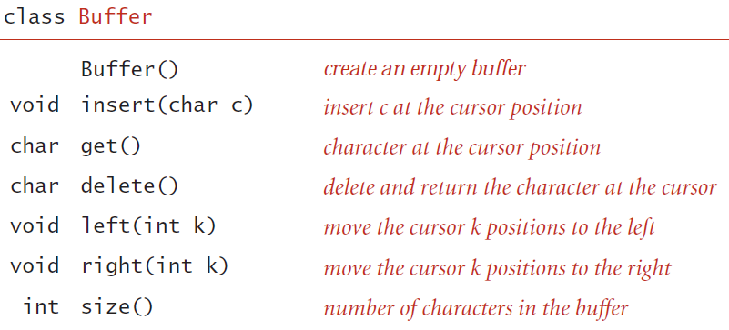
Use stack from c++ STL which provides the following operations:
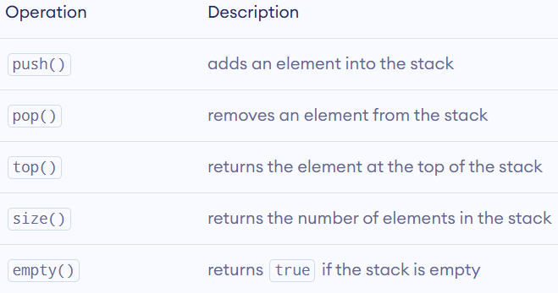
Hint : Use two stacks.
Name:______________________ ID#______________ PC#____________
Steque. A stack-ended queue or steque is a data type that supports push, pop, and enqueue. Develop a circular array-based implementation. All the operations should complete in constant time.
Required methods:
- void push(Item item): Adds an item to the top of the steque (where Item is template based).
- Item pop(): Removes and returns the item from the top of the steque.
- void enqueue(Item item): Adds an item to the end of the steque.
- bool isEmpty(): Returns true if the steque is empty, false otherwise.
- int size(): Returns the number of items in the steque.
- void printSteque(): prints items from top to bottom.

Name:______________________ ID#______________ PC#____________
Implement an Expression Evaluation API which performs the following:
- Evaluates an infix expression using a two-stack approach [Dijkstra’s approach].
double evaluateInfix(string expression)
- Parameters: expression - the infix expression to be evaluated

- Evaluates a postfix expression using a single-stack approach.
double evaluatePostfix(string expression)

- Parameters: expression - the postfix expression to be evaluated
- Checks if an infix expression is valid.

bool isValidInfix(string expression)

- Checks if a postfix expression is valid.

bool isValidPostfix(string expression)

Requirements:
1. Use a stack data structure to evaluate the postfix expression.
2. Handle the following operators: +, -, *, /.
3. Implement error handling for:
- Invalid postfix expressions.
- Division by zero.

Name:______________________ ID#______________ PC#____________
You are tasked with implementing a music player application using a circular queue where each node represents a music record. Each record has its title, artist, and duration, and the circular queue should provide a continuous loop for playing music. Implement the following methods:
- AddRecord(title, artist, duration): Add a new music record to the playlist with the given title, artist, and duration. Ensure that the records are added to the circular singly linked list in the order they are inserted.
- RemoveRecord(title): Remove a music record with the specified title from the playlist.
- PlayNext(): Move to the next music record in the playlist and return its information (title, artist, and duration).
- ListAllRecords(): Traverse the circular singly linked list and print all music records with their titles, artists, and durations.
- ShufflePlaylist(): Randomly rearrange the music records in the playlist.
Ensure that the circular queue list allows for continuous play, and the traversal can loop back to the beginning after reaching the end.

Name:______________________ ID#______________ PC#____________
Design a ticket reservation system for a theater using a queue. Customers arrive at the ticket counter and wait in line to purchase tickets. Each customer has a customer ID, name, and number of tickets required. The system processes customers based on the First-Come, First-Served (FCFS) principle. Additionally, implement a priority system for VIP customers who are served immediately upon arrival.

Requirements:
- Customer Queue Management:
  - Implement a standard queue for regular customers.
  - Implement a standard queue for VIP customers.
- Operations:
  - Add Regular Customer: Adds a regular customer to the end of the queue for regular customers.
  - Add VIP Customer: Adds a VIP customer to VIP customers’ queue. This customer is served before regular customers.
  - Process Customer: Serve the next customer in line (VIP customers are served first).
  - Cancel Reservation: Remove a customer from the queue by their ID.
  - Display Queue: Show all customers currently waiting in the queue (VIP and regular).
- Simulation:
  - Simulate the reservation process by adding, serving, and canceling customers.
  - Ensure that VIP customers always get priority.
You can use queues from c++ STL whose functions are listed below.
push() | Inserts an element at the back of the queue.
pop() | Removes an element from the front of the queue.
front() | Returns the first element of the queue.
back() | Returns the last element of the queue.
size() | Returns the number of elements in the queue.
empty() | Returns true if the queue is empty.

Also, you may want to use unordered_map from STL whose functions are listed below.
insert() | insert one or more key-value pairs
count() | returns 1 if key exists and 0 if not
find() | returns the iterator to the element with the specified key
at() | returns the element at the specified key
size() | returns the number of elements
empty() | returns true if the unordered map is empty
erase() | removes elements with specified key
clear() | removes all elements

Name:______________________ ID#______________ PC#____________

You are tasked with implementing a task scheduler for a space mission control center using a priority queue (using a Max Heap). Each task represents a critical operation during a space mission. The tasks have descriptions, and their priority levels represent the criticality of the operation. Implement the following methods:
- AddTask(description, priority): Add a new mission operation task with the given description and priority.
- RemoveHighestPriorityTask(): Remove and execute the most critical operation from the mission task queue.
- isQueueFull(): Check if the queue is currently at full capacity.
- ListAllTasks(): Display all mission tasks, ordered by their priority levels.

Name:______________________ ID#______________ PC#____________
You are in charge of optimizing a robot assembly line, and you need to implement a priority queue (using a Max Heap) to manage different tasks related to robot production. Each task represents a specific job in the assembly line with a description and a priority level. Additionally, you need to keep track of whether the assembly line is full or empty. Implement the following methods:
- AddTask(description, priority): Add a new job to the robot assembly line with the given description and priority.
- RemoveHighestPriorityTask(): Remove and execute the highest priority job from the assembly line.
- IsAssemblyLineEmpty(): Check if the assembly line is currently empty.
- IsAssemblyLineFull(): Check if the assembly line is currently at full capacity.
In this scenario, tasks could represent various jobs in the robot assembly process, such as welding, painting, or quality control. The priority levels might indicate the urgency or complexity of each task. The additional tasks of checking if the assembly line is empty or full add a practical aspect to the problem.
Name:______________________ ID#______________ PC#____________
Implement a task manager using a Heap data structure, where each node represents a task with a task name and its priority. The priority is an integer value, and tasks should be stored in descending order based on their priority. Implement the following methods:

- AddTask(taskName, priority): This method should add a new task to the task manager with the given task name and priority. Ensure that the tasks are maintained in descending order based on priority after each addition.

- RemoveTask(taskName): Implement this method to remove a task with the specified task name from the task manager. If multiple tasks have the same name, remove only the one with the highest priority. If the task with the given name does not exist, provide an appropriate indication.

- GetHighestPriorityTask(): This method should return the task with the highest priority from the task manager.

- ListAllTasks(): Implement this method to traverse the linked list and print all tasks (task name and priority) in the order they are stored.

Your implementation should consider the efficient insertion and removal of tasks while maintaining the descending order based on priority.

Name:______________________ ID#______________ PC#____________
Maze Generation using Union-Find
Generate a perfect 2D maze with a size of 10x10 cells using union-find data structure (weighted quick-union). A perfect maze is one where every cell is reachable from every other cell.
Requirements:
1. Initialize the maze as a grid of cells, where each cell is initially a separate set in the union-find data structure.
2. Use the union-find data structure to randomly connect adjacent cells in the maze, ensuring that the resulting maze is perfect.
3. Output the generated maze as a 10x10 grid of characters, where:
- '#' represents a wall
- ' ' represents an open path
- 'S' represents the starting point (top-left cell)
- 'E' represents the ending point (bottom-right cell)
Name:______________________ ID#______________ PC#____________

Implement a Union-Find data structure using quick-union (no need to be weighted) to solve a dynamic connectivity problem on a 2-D grid. The grid represents islands (1) surrounded by water (0), and your task is to simulate building bridges that connect islands. Note, two adjacent 1s (horizontally or vertically) are part of the same island.
Write a function connectIslands that takes an initial grid and a sequence of bridge positions. connectIslands function:
- Processes each bridge in sequence, converting the specified cell from water to land.
- Merges adjacent cells using Union-Find when a new bridge is built.
- Updates and prints the number of connected components after each bridge.

Example:
vector<vector<int>> grid = { {1, 0, 0, 1},
{0, 1, 0, 1},
{1, 0, 1, 0} };
vector<vector<int>> bridges = {{0, 1}, {1, 0}, {2, 3}};
Calling connectIslands(grid, bridges) prints 4 3 3.

Name:______________________ ID#______________ PC#____________
Interval Tree Implementation using Binary Search Tree (BST)
Design and implement an interval tree data structure using a red-black tree to efficiently manage overlapping intervals. The BST property is maintained based on the start value of each interval. Each node in the BST represents an interval defined by a start and end value.
Requirements:
1. Insertion: Implement an efficient insertion method to add new intervals to the tree while maintaining the BST property.
3. Search: Develop an efficient search algorithm to find all overlapping intervals for a given query range.
4. Rebalancing: Implement a self-balancing mechanism to maintain the BST property after insertions.
5. In-order Traversal: Create an in-order traversal method to print intervals in ascending order.

Interval Tree Node Structure:
Each node in the interval tree should contain the following information:
- start: The start value of the interval.
- end: The end value of the interval.
- max_end: The maximum end value of the subtree rooted at this node.
- left: A pointer to the left child node.
- right: A pointer to the right child node.

Example:
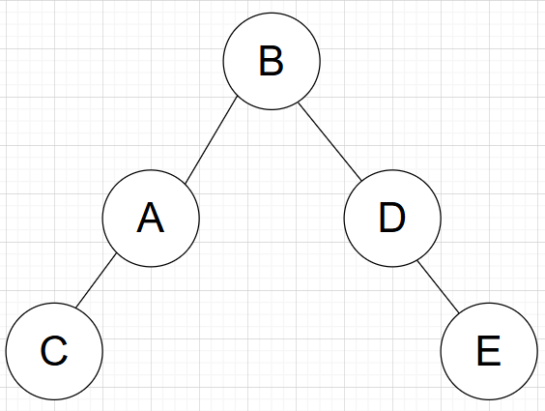
| Interval | Start | End |
|------------|-------|------|
| A | 10 | 20 |
| B | 15 | 25 |
| C | 5 | 15 |
| D | 20 | 30 |
| E | 25 | 35 |
Name:______________________ ID#______________ PC#____________
You are tasked with developing a contact management system using a balanced Binary Search Tree (BST) (red-black tree). Each contact record includes a unique contact ID, name, phone number, and email address. Implement a program to assist users with the following operations:
- Insert a contact record:
  - Allow users to add a new contact to the system, ensuring that the contact ID is unique.
- List all contacts by ID in order:
  - Display the contact information in ascending order based on the contact ID.
- Find a record using contact ID:
  - Enable users to search for a contact by entering the contact ID, and display the corresponding contact details.
- Delete a record using contact ID:
  - Provide an option to delete a contact record based on the contact ID (Hibbard deletion).

Ensure that the Binary Search Tree maintains the order of contact IDs to facilitate efficient searching and retrieval of contact information. Write a program that fulfills these requirements to streamline contact management for users.

Name:______________________ ID#______________ PC#____________

- You have to build an inventory system using a balanced binary search tree (Binary Search Tree) (red-black tree). The inventory record includes product id, date, transaction type, quantity, price per unit. Create BST (Binary Search Tree) to store the data using product id. Write a program to help the manager by implementing the following operations:
  - Insert a product record.
  - List all product by id in order.
  - Find record using product id
  - Delete record using product id (Hibbard deletion)

Name:______________________ ID#______________ PC#____________

Create a family tree organizer using a binary search tree. Each node in the tree represents a family member with their name and relationship (e.g., parent, child). Implement the following methods:
- AddFamilyMember(name, relationship): Add a new family member to the tree with the given name and relationship. Ensure that family members are added to the BST based on their names.
- RemoveFamilyMember(name): Remove a family member with the specified name from the family tree.
- FindOldestFamilyMember(): Find and return the name of the oldest family member in the tree.
- ListFamilyMembers(): Traverse the BST in-order and print all family members with their names and relationships.

Name:______________________ ID#______________ PC#____________
Design and implement a hash table using separate chaining to store book records. Each book record consists of the following attributes: Book ID, Book Title, Author. It must maintain load factor (N/M ratio) within limits.

Implement the following methods:

1. Insert(bookRecord): Insert a new book record into the hash table.
2. Find(bookTitle): Find and return the book record(s) with the specified title.
3. Delete(bookTitle): Delete the book record(s) with the specified title from the hash table.
4. DisplayAllBooks(): Display all book records stored in the hash table.

Name:______________________ ID#______________ PC#____________
- You have to maintain information for a shop owner. For each of the products sold in his/hers shop the following information is kept: a product code, name, price, amount in stock, date received, and expiration date. For keeping track of its stock, the clerk would use a computer program based on a hashing data structure by using linear probing approach in open addressing and by using product code. It must maintain load factor (N/M ratio) within limits. Write a program to help this person, by implementing following the following operations:
- Insert a product record
- Delete a product record
- Find an item by its code
- List all expired items
- List all items in stock.

Name:______________________ ID#______________ PC#____________
- Implement a program to build a telephone directory using open addressing method (linear probing) in Hashing. Telephone directory consists of person’s record that includes inserting person’s name, address, and telephone number. Implement the following methods. It must maintain load factor (N/M ratio) within limits.
- Insert person record in telephone directory
- Find a person record by providing the name of a person.
- Delete: Use name of a person to delete the person’s record.
- Display telephone directory.

Name:______________________ ID#______________ PC#____________

You are tasked with implementing a book reader application using separate chaining method of Hashing. The buckets will hold all the pages of a chapter. Each page has its content, page number, and a link to the next and previous pages. Implement the following methods:
- AddPage(chapterName, content): Add a new page to the chapter with the given content. Ensure that the pages are added to the chapter in the order they are inserted, and each page is assigned a unique page number. Also, each chapter has its own page numbers starting from 1.
- RemovePage(chapterName, pageNumber): Remove a page with the specified page number from the given chapter of the book.
- ReadPage(chapterName, pageNumber): Retrieve and display the content of a specific page with the given page number and chapter name. If the page is not found, provide an appropriate indication.
- ListAllPages(): Traverse the table and print all pages with their chapter names and page numbers and content.
You may want to use std::list from c++ STL. Following are some useful functions it provides.
front() – Returns the value of the first element in the list.
back() – Returns the value of the last element in the list.
push_front() – Adds a new element ‘g’ at the beginning of the list.
push_back() – Adds a new element ‘g’ at the end of the list.
pop_front() – Removes the first element of the list, and reduces the size of the list by 1.
pop_back() – Removes the last element of the list, and reduces the size of the list by 1.
insert() – Inserts new elements in the list before the element at a specified position.
size() – Returns the number of elements in the list.
begin() – begin() function returns an iterator pointing to the first element of the list.
end() – end() function returns an iterator pointing to the theoretical last element which follows the last element

Name:______________________ ID#______________ PC#____________
You’re hosting a party. Unfortunately, many of your invitees are sworn enemies of each other. As the organizer, to ensure aggregate happiness, you’d like to separate the party-goers into two groups such that no two members of the same group are enemies. You’d like to know if this is possible for your party.
Your friend Euler gives you a graph representing enmity-relationships among the invitees: Each invitee is mapped to a vertex, and an edge (u, v) means invitee ‘u’ and invitee ‘v’ are enemies.
Create a Graph class which uses adjacency list representation and a SeparableEnemySolver class to check if the graph is separable.
Implement the function isSeparable() in the SeparableEnemySolver class, which returns true if the invitees represented by g are separable, and false otherwise.

